Included in all subjects across the curriculum will be the 4 areas of SEND: Communication and Interaction, Cognition and Learning, Social, emotional and health difficulties, Sensory and / or physical needs.
Theme | Autumn 1 | Autumn 2 | Spring |  | Summer 1 | Summer 2
Theme | All about me and Ourselves! | Autumn / Winter | Transport |  | Animals and Mini Beasts | The Sea
Sensory texts, linked to topic and includes coverage of a variety of genres (Non Fiction, Fiction and Poetry)
Phonics is taught following the Little Wandle Scheme of work.
Key Texts:  Communication+  Interaction | We are all different (Sensory story Twinkl  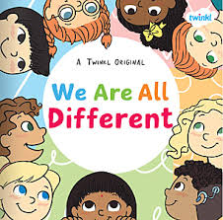  My mum and dad make me laugh  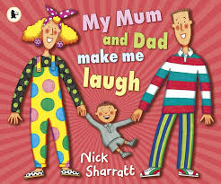  I am a super hero (sensory soup)  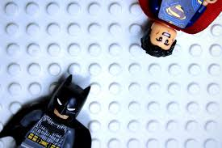 | Leaf man (Sensory soup)  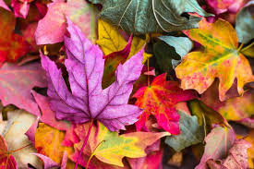  Winter snow (Sensory soup)    Stick Man  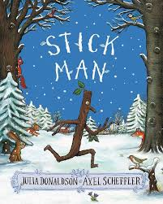 | The train ride  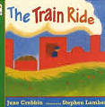  Our Little Orange car (Sensory soup)  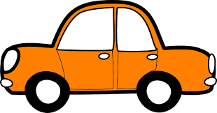  Duck in the Truck  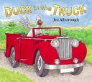 |  | Were going on a bear hunt  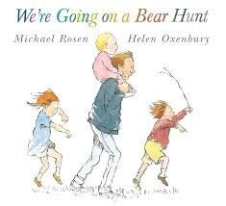  The Very Hungry Caterpillar  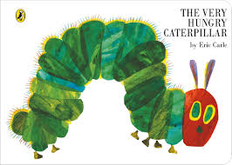  Ladybird/Ladybird (Sensory soup)  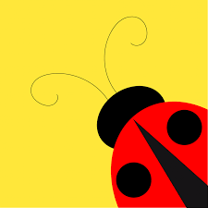 | Commotion in the ocean  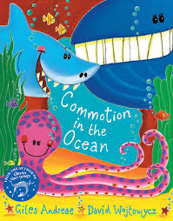  The Rainbow fish  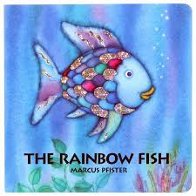  Barry the fish with fingers  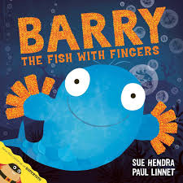
Nursery Rhymes- | Round and round the garden​  Hey diddle diddle​  Hickory dickory dock​  Grand old duke of York​  Polly put the kettle on​  Little miss muffet | Firework night​  5 little men in a flying saucer​  Twinkle twinkle​  Little bo peep​  Two little dickie birds​  Five mince pies​  Five little snowmen | Baa baa black sheep​  Wheels on the bus​  Five little ducks​  Jack and jill​  Ten in a bed​  Humpty dumpty  Incy wincy​  Dingle Dangle Scarecrow​  I’m a little teapot​  Mary had a little lamb​  Pat a cake​  Ring a ring o roses |  | Old McDonald​  Horsie Horsie​  Here is a bee hive​  Fish alive​  Mary Mary contrary​  Muffin man | Pussy Cat pussy cat​  One elephant​  Piggy went to market​  5 little monkey in tree​  Old mother hubard​  Miss Polly had a doll​  5 little fishes
Reading | Ongoing: Phonics, Mechanics of Reading, Reading Environment, Reading for Pleasure and Comprehension.
Writing | Ongoing: Gross Motor, Fine Motor, Mark Making Sound Discrimination and Early Writing
Maths | Ongoing: Number, Colour, Shape, Measure, Position and Time
Science | Senses | Seasonal Changes | Pushes and Pulls |  | Animals | Materials
Computing | Technology around us (Mini Mash) |  | Robots (Mini Mash) |  | Drawing Skills
DT |  |  | Creating and making vehicles |  | Sculpting
RE  The World | Festivals and Celebrations |  | Leaders |  | Belonging
PE | Parachute | Gymnastics – PE hub | Twinkl – Transport and travel | Balls | Mix of agility and dance – pe hub and twinkl | Games – PE hub
Music | Songs and instruments |  | Rhythm |  | Exploring instruments
Art | Portraits - drawing | Painting / printing – Based on seasons | Printing and strokes – based on transport |  | Collage - animals | Collage - sea
RHSE | Ongoing: Communicating basic needs, Friendships and Relationships Education, Behaviours for learning, Attention and Listening, Self -care and Intimate care
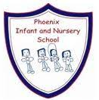
The Nest – Long Term Plan – Cycle A
Language Opportunities Values Excellence Diversity

